NOISE POLLUTION MONITORING

PHASE-3 DOCUMENT SUBMISSION

***ABSTRACT:***

This research presents an advanced noise pollution monitoring system designed to address the growing concerns associated with urban noise pollution. The system employs a network of high-precision acoustic sensors and real-time data processing to monitor and analyze noise levels across the city. It offers a user-friendly interface for data visualization and provides invaluable insights for urban planners and policymakers to mitigate noise pollution's adverse effects on public health and well-being.

***INFORMATION OF NOISE POLLUTION MONITORING***

Noise Pollution Monitoring is the process of measuring and assessing levels of noise in the environment to understand and mitigate the impact of excessive noise on human health and the environment. Below are key points regarding noise pollution monitoring:

1. Importance of Noise Monitoring:
   * Noise pollution can have adverse effects on human health, including hearing impairment, sleep disturbances, and increased stress levels.
   * It can also impact wildlife, disrupt ecosystems, and lead to communication interference.
2. Types of Noise Monitoring:
   * Continuous Monitoring: Real-time data collection using permanent or semi-permanent monitoring stations.
   * Area-Based Monitoring: Involves strategically placing sensors to monitor noise levels across specific areas.
   * Personal Noise Dosimetry: Monitoring individual exposure to noise in workplaces or specific settings.
   * Event-Based Monitoring: Captures data during specific events, such as construction work or transportation activities.
3. Noise Measurement Units:
   * Noise is typically measured in decibels (dB), a logarithmic scale that quantifies the intensity or loudness of sound.
   * Common metrics include L10 (the noise level exceeded for 10% of the measurement period), L50, L90, and equivalent continuous noise levels (Leq).
4. Noise Monitoring Equipment:
   * Sound Level Meters: Portable devices for on-site noise measurements.
   * Noise Dosimeters: Worn by individuals to assess personal exposure.
   * Environmental Noise Monitoring Stations: Fixed installations for continuous monitoring in various settings.
   * Remote Sensing: Satellite and aerial technology for large-scale monitoring.
5. Data Analysis and Reporting:
   * Noise monitoring data is typically analyzed to determine the level, duration, and patterns of noise pollution.
   * Data can be visualized through graphs and maps, helping authorities and researchers to identify trends and hotspots.
   * Reporting may involve providing recommendations for noise mitigation measures.
6. Applications of Noise Monitoring:
   * Urban Planning: To assess and mitigate noise pollution in cities and residential areas.
   * Transportation: Monitoring noise levels near airports, highways, and railways.
   * Industrial Settings: Ensuring compliance with noise regulations in manufacturing facilities.
   * Environmental Impact Assessments: Determining the impact of noise on ecosystems and wildlife.
   * Health and Safety: Protecting workers from excessive noise exposure in the workplace.
   * Community Awareness: Engaging citizens in understanding and addressing noise pollution issues.
7. Regulations and Standards:
   * Many countries and regions have regulations and standards in place to limit noise pollution, and monitoring is crucial to ensure compliance.
8. Technological Advancements:
   * Advancements in sensor technology, data analysis, and IoT have led to more sophisticated and accurate noise monitoring systems.
   * Machine learning and AI are increasingly used to analyze and predict noise patterns.
9. Public Involvement:
   * Citizen science initiatives and public reporting apps allow individuals to participate in noise pollution monitoring.
   * Public engagement can help raise awareness and drive action to reduce noise pollution.
10. Noise Mitigation:
    * Data from noise monitoring is used to develop and implement strategies to reduce noise pollution, such as noise barriers, regulations, and land use planning.

***OBJECTIVES OF NOISE POLLUTION MONITORING SYSTEMS:***

* Assess Noise Exposure
* Compliance Monitoring
* Real-Time Alerts
* Data Collection and Analysis
* Public Awareness
* Source Identification
* Long-Term Planning
* Research and Policy Development

***1. Noise Exposure:***

One of the primary objectives of noise pollution monitoring systems is to assess noise exposure accurately. By continuously measuring and recording noise levels in specific areas, these systems can provide data that helps identify high-exposure locations. This information is vital for understanding the extent of noise pollution and its impact on individuals and communities.

**Access the Monitoring System:**

Log in to the noise monitoring system. This might be a web-based application or a software program installed on a computer or dedicated hardware.

**Select the Monitoring Site:**

Choose the location or site for which you want to access noise exposure data. Most monitoring systems allow you to select specific monitoring points or areas.

**Set Time Parameters:**

Specify the time frame for which you want to access data. This can be a specific date, time range, or even a continuous monitoring period.

**Retrieve Data:**

Use the system's interface to retrieve noise exposure data. This data is typically presented as sound level measurements over time, usually in decibels (dB), with timestamps.

**Analyze the Data:**

Once you have the data, you can analyze it to calculate various noise exposure metrics. The most common metric is LEX, which represents the equivalent continuous noise level over a specific time period. It takes into account the noise level and the duration of exposure.

**Interpret the Results:**

Interpret the data to understand the noise exposure at the selected location. Pay attention to peak noise levels, LEX values, and any trends or patterns in the data.

**Take Action:**

Depending on your findings, take appropriate action to mitigate noise exposure if it exceeds permissible limits or poses a risk to health and safety. This might involve implementing noise control measures or adjusting work schedules.

***2.Compliance Monitoring:***

Noise pollution regulations and standards exist in many regions to protect public health and maintain a suitable quality of life. Noise monitoring systems help enforce these regulations by ensuring that businesses, construction sites, and other activities adhere to permissible noise levels. This objective is vital for preventing noise-related health issues and maintaining a harmonious environment.

**Regulatory Standards and Limits:**

First, it's essential to be aware of the regulatory standards and permissible noise limits applicable to the location or industry you are monitoring. These standards can vary by region, industry, and time of day. Common standards include occupational noise exposure limits and community noise levels during daytime and nighttime hours.

**Select Monitoring Locations:**

Identify the specific locations or monitoring points where compliance needs to be assessed. This could be near sensitive receptors such as residential areas, workplaces, or areas close to machinery or equipment generating noise.

**Configure Monitoring Equipment:**

Ensure that the noise monitoring equipment is properly set up and calibrated to accurately measure noise levels. This equipment may include noise sensors, sound level meters, or noise dosimeters. Make sure that the equipment is in good working order.

**Collect and Record Data:**

Start monitoring noise levels at the selected locations. The monitoring system will continuously or periodically collect data, including decibel levels and timestamps. This data is usually stored and can be retrieved for analysis.

**Real-Time Alerts:**

Many modern noise monitoring systems provide real-time alerts if noise levels exceed predefined limits. This can help take immediate action if there is a compliance breach.

**Data Analysis:**

After data collection, analyze the recorded noise levels. Calculate various metrics, such as Lmax (maximum noise level), Lavg (average noise level), Ldn (day-night noise level), or Lden (day-evening-night noise level), depending on the applicable regulations.

**Compliance Assessment:**

Compare the measured noise levels to the established noise limits and standards. Determine if the location is in compliance with these regulations. If the noise levels exceed the permissible limits, it indicates non-compliance.

**Reporting:**

Generate compliance reports that include the monitored data, assessment results, and any actions taken in case of non-compliance. These reports are often used for regulatory reporting, internal documentation, and potential legal purposes.

**Mitigation and Action:**

If non-compliance is identified, take appropriate actions to mitigate noise levels. This might involve adjusting operations, implementing noise control measures, or reevaluating work schedules to reduce noise during sensitive periods.

**Documentation and Record Keeping:**

Maintain records of all compliance monitoring activities, data, and reports. Proper documentation is crucial for demonstrating compliance and addressing any regulatory inquiries.

***3. Real-Time Alerts:***

Another important objective of noise pollution monitoring systems is to provide real-time alerts and notifications. When noise levels exceed permissible limits, the system can trigger alarms or send alerts to authorities, allowing for immediate action to mitigate noise pollution sources. Real-time alerts ensure a more rapid response to noise-related issues.

**Threshold Configuration:**

Users set specific noise level thresholds or limits within the noise monitoring system. These thresholds are often based on regulatory standards, safety guidelines, or project-specific requirements.

**Continuous Monitoring:**

The noise monitoring system continuously measures and records noise levels in real time using sensors or sound level meters. The data collected is processed and compared to the configured thresholds.

**Alert Generation:**

When the measured noise levels exceed the defined thresholds, the system generates an alert. The alert can take various forms, including visual warnings on a graphical user interface, audible alarms, and automated notifications via email, SMS, or other communication channels.

**Immediate Notification:**

Real-time alerts are designed to notify relevant personnel or stakeholders as soon as the threshold is breached. This allows for rapid response and intervention to address the issue.

**Actionable Information:**

The alerts often include additional information, such as the specific location where the threshold was exceeded, the time of the breach, and the severity of the noise level violation. This information helps users identify the source of the noise and make informed decisions.

**Customization:**

Users can often customize alert settings to match their specific needs. This may include setting different thresholds for different monitoring locations, defining the types of alerts (e.g., high-priority or low-priority), and specifying the recipients of alerts.

**Workplace Safety:**

To protect workers from excessive noise exposure, especially in industries where hearing protection is required when noise levels are high.

**Community Noise Monitoring:**

To address noise complaints and ensure that noise emissions from industrial facilities, construction sites, or transportation hubs do not disrupt local communities.

**Construction Site Management:**

To maintain compliance with noise regulations and manage construction activities to minimize noise disturbances in nearby residential areas.

**Environmental Monitoring:**

To protect wildlife in ecologically sensitive areas where noise pollution can have adverse effects.

**Quality Control:**

In manufacturing and production facilities to maintain product quality by ensuring that equipment operates within acceptable noise levels.

***4. Data Collection and Analysis:***

Noise pollution monitoring systems collect extensive data over time, which is crucial for in-depth analysis. This objective aims to store and analyze noise data to identify trends, patterns, and sources of noise pollution. Such analysis can help policymakers and environmentalists make informed decisions about urban planning, zoning, and noise control measures.

**Measurement Devices:** Noise monitoring systems use various measurement devices, such as sound level meters, noise dosimeters, and remote sensors, to capture noise data. These devices are strategically placed at monitoring points, and they continuously or periodically measure noise levels.

**Sensor Placement:** Monitoring points are selected based on the specific monitoring objectives, which may include assessing noise exposure, evaluating noise pollution, or ensuring compliance with regulations. Sensors are placed at these points to capture noise information.

**Continuous Monitoring:** In many cases, noise monitoring is carried out in real-time, and data is collected 24/7. This ensures that noise events, such as spikes in noise levels, are not missed.

**Data Recording:** Noise levels are recorded over time and are typically measured in decibels (dB). Data is collected with corresponding timestamps to understand when noise events occurred.

**Environmental Data:** Some monitoring systems also collect environmental data alongside noise data, including temperature, humidity, wind speed, and direction. This information can help in understanding how environmental factors influence noise levels.

**Data Analysis:**

**Data Preprocessing:** Raw noise data may undergo preprocessing, which includes tasks like data cleaning (removing outliers and errors), data normalization, and synchronization with environmental data.

**Statistical Analysis:** Statistical analysis is performed to calculate various metrics, such as Lmax (maximum noise level), Lavg (average noise level), Ldn (day-night noise level), and Lden (day-evening-night noise level). These metrics provide insights into noise exposure and pollution.

**Temporal Analysis:** Data is analyzed over time to identify patterns and trends. This may involve examining daily, weekly, or seasonal variations in noise levels.

**Spatial Analysis:** If multiple monitoring points are in use, spatial analysis can be conducted to understand how noise varies across different locations within a specific area.

**Compliance Assessment:** If the monitoring is for compliance purposes, the data is compared to regulatory standards and limits to assess whether noise levels are within the acceptable range. Non-compliance issues are identified through this analysis.

**Identification of Noise Sources:** By analyzing noise data and its characteristics, it's often possible to identify specific sources of noise, which is useful for mitigating noise pollution.

**Report Generation:** Analysis results are used to generate reports that provide a summary of the collected data, key findings, and actionable insights. These reports may be used for compliance reporting, internal documentation, or communication with stakeholders.

**Actionable Insights:** The analysis results can be used to make informed decisions. For example, if noise levels exceed permissible limits, steps can be taken to reduce noise emissions or implement noise control measures.

***5.Public Awareness:***

Raising public awareness about noise pollution is an essential goal of monitoring systems. By providing accessible information and reports to the public, these systems help individuals and communities understand the severity of the issue and take steps to reduce noise pollution in their areas. Public awareness is a critical aspect of noise pollution mitigation.

***6. Source Identification:***

Noise pollution monitoring systems are used to identify and locate specific sources of noise pollution. This can include industrial facilities, transportation routes, and even individual vehicles. Accurate source identification is essential for targeted noise reduction measures and urban planning adjustments.

***7. Long-Term Planning:***

Long-term planning to reduce noise pollution is a key objective of monitoring systems. The data collected over time allows for strategic decisions on urban development, transportation, and zoning to minimize noise pollution. This objective ensures that noise pollution control becomes an integral part of city planning.

***8.Research and Policy Development:***

Noise pollution monitoring systems contribute to scientific research and policy development. The data they provide can support the creation of evidence-based policies to address noise pollution. Researchers can use this data to better understand the effects of noise on health and quality of life, leading to more effective policies.

***Conclusion:***

Noise pollution monitoring systems serve a multitude of essential objectives, ranging from assessing noise exposure to supporting research and policy development. These systems are indispensable tools in the fight against noise pollution, helping to create quieter, healthier, and more pleasant environments for individuals and communities. By achieving these objectives, noise pollution monitoring systems play a crucial role in enhancing the quality of life and promoting environmental sustainability.

***Sensors used in noise pollution monitoring:***

* Sound Level Meters
* Microphones
* Noise Dosimeters
* Environmental Noise Monitors
* Vibration Sensors
* Weather Stations
* GPS Receivers
* Data Loggers
* Audio Recording Equipment
* Telemetry and Communication Equipment

***Sound Level Meters:***

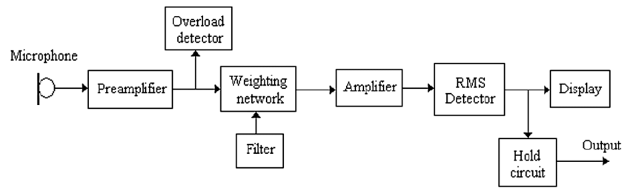

sound-level meter, device for measuring the intensity of noise, music, and other sounds. A typical meter consists of a microphone for picking up the sound and converting it into an electrical signal, followed by electronic circuitry for operating on this signal so that the desired characteristics can be measured.

# ***Microphones:***

These transducers capture sound and convert it into electrical signals, which are then processed by sound level meters. Condenser microphones are commonly used in noise monitoring applications due to their sensitivity and accuracy.

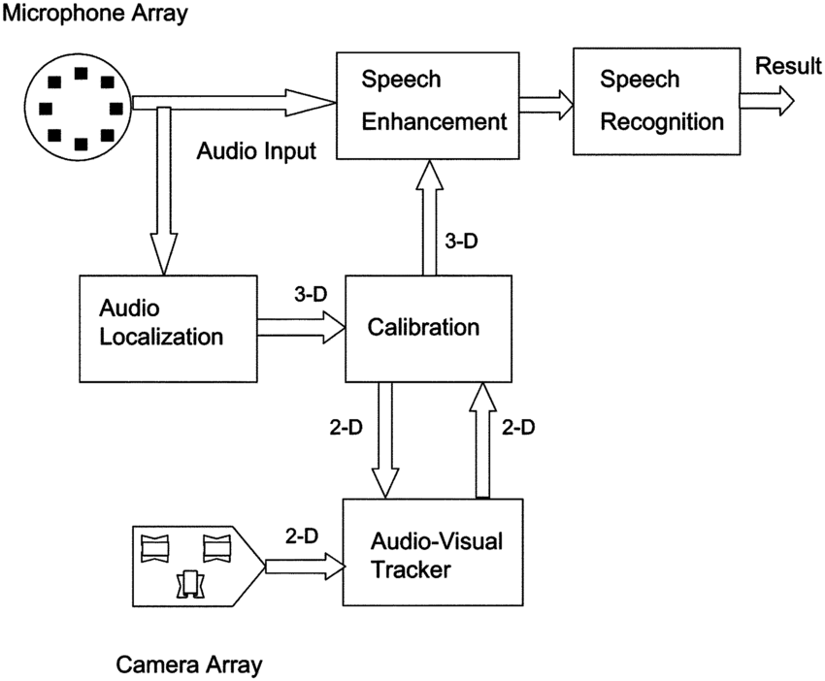

# ***Noise Dosimeters:***

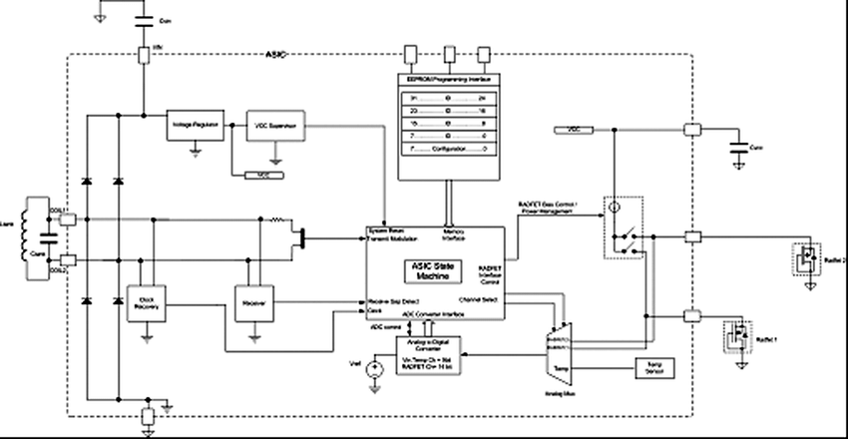

These personal noise exposure monitoring devices are worn by individuals to measure their exposure to noise over a specific time period, typically an entire work shift. Dosimeters provide data on the cumulative noise exposure.

Dosimeters available today can provide an output in dose or TWA using various exchange rates (e.g., 3, 4, and 5 dB), 8-hr criterion levels (e.g., 80, 84, 85, and 90 dBA), and sound measurement ranges (e.g., 80 to 130dBA).

Dosimeters are issued to measure and record the amount of occupational radiation dose an individual receives as required by state and federal regulations.

# ***Environmental Noise Monitors:***

These are stationary or semi-permanent monitoring stations installed in outdoor locations to continuously measure noise levels in the environment. They often include multiple microphones to monitor sound from different directions and provide a more comprehensive assessment of noise pollution.

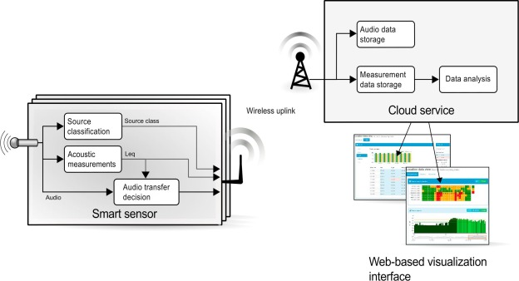

Noise may be measured using a sound level meter at the source of the noise. Alternatively, an organization or company may measure a person's exposure to environmental noise in a workplace via a noise dosimeter. The measurements taken using either of these methods will be evaluated according to the standards below.

***Vibration Sensors:***

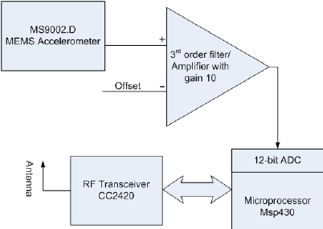

In some cases, noise pollution is accompanied by vibration, especially near sources like heavy machinery or construction sites. Vibration sensors are used to detect and measure ground or structural vibrations that may contribute to noise pollution.

Vibration sensors designed for monitoring applications are used to monitor motors, critical pumps, fans, gearboxes, and compressors in the oil and gas industry.

# ***Weather Stations:***

Weather conditions can affect sound propagation, and therefore, monitoring stations may include weather sensors to account for factors like temperature, humidity, and wind speed that impact noise dispersion.

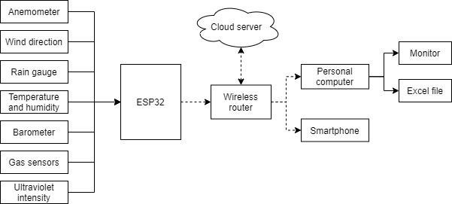

At the most basic level, an automatic weather station works by measuring atmospheric conditions and transmitting them to a network, forecaster, or display. They use special instruments to measure the surface weather observations we mentioned above.

# ***GPS Receivers:***

Some noise monitoring systems include GPS receivers to geospatially map noise data, providing information about where noise pollution is most prevalent and aiding in urban planning and policy decisions.

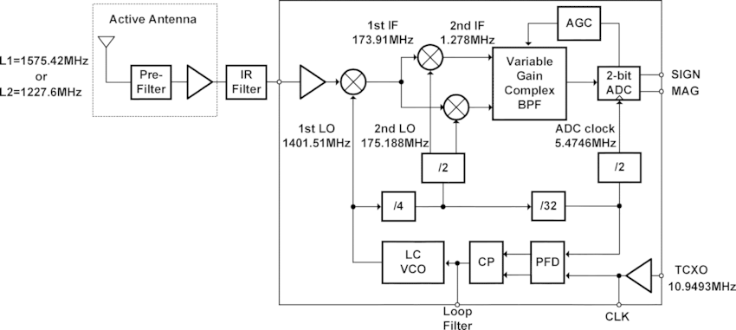

GPS modules contain tiny processors and antennas that directly receive data sent by satellites through dedicated RF frequencies. From there, it'll receive timestamp from each visible satellites, along with other pieces of data.

A receiver, like you might find in your phone or in your parents car, is constantly listening for a signal from these satellites. The receiver figures out how far away they are from some of them. Once the receiver calculates its distance from four or more satellites, it knows exactly where you are. Presto!

# ***Data Loggers:***

Data loggers are used to record noise levels continuously over an extended period, allowing for long-term trend analysis. These devices are often combined with SLMs or microphones.

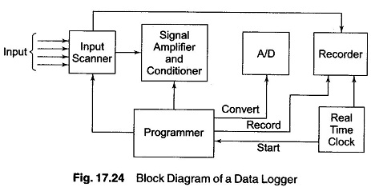

The input scanner is an automatic sequence switch which selects each signal in turn. Low level signals, if any, are multiplied to bring them up to a level of 5 V. If the signals are not linearly proportional to the measured parameter, these signals are linearised by the [signal conditioner](https://www.eeeguide.com/single-channel-data-acquisition-system/).

# ***Audio Recording Equipment:***

Audio recording devices capture ambient sounds in addition to measuring noise levels. This can be useful for identifying specific sources of noise pollution and for collecting evidence in legal cases.

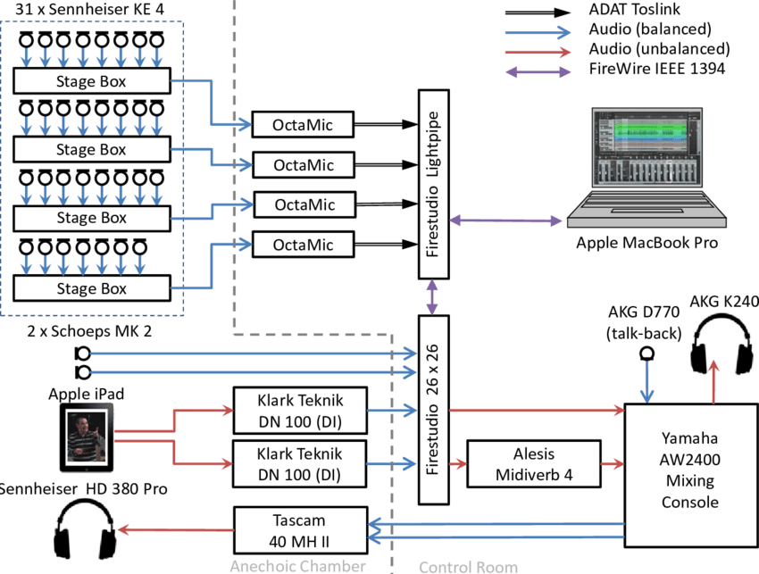

***Telemetry and Communication Equipment:***

To transmit data from monitoring stations to central databases or control centers, telemetry and communication equipment, such as wireless or internet-connected systems, may be employed.

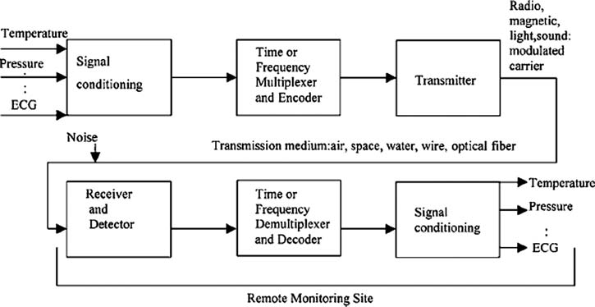

Basic telemetry systems consist of a modulator, a voltage-controlled oscillator (VCO), and a power supply for the. The signal from the strain gage bridge is used to pulse modulate a constant-amplitude square wave. The output pulse width is proportional to the voltage from the bridge**.**

# ***ALGORITHM:***

**Step 1: Hardware Setup**

* Acquire a Raspberry Pi or similar single-board computer.
* Connect a USB microphone to the Raspberry Pi.
* Ensure your Raspberry Pi is properly configured and connected to the internet.

**Step 2: Install Required Libraries**

* You'll need Python libraries for audio recording and processing. The most commonly used library for this is PyAudio. You can install it using pip

**Step 3: Create a Python Script**

* You can create a Python script that captures audio data and calculates noise levels. Here's a simplified example:
* This script captures audio data from the microphone, calculates the RMS (Root Mean Square) value, and prints it in real-time. If the noise level exceeds the specified threshold, it will be displayed.

**Step 4: Run the Script**

* Save the script to your Raspberry Pi and run it using Python:
* The system will continuously monitor noise levels and display them in your terminal. You can adjust the THRESHOLD variable to change the sensitivity of the system to noise.

***PROGRAM:***

import sounddevice as sd

import pandas as pd

import time

# Constants

SAMPLE_RATE = 44100 # You can adjust this depending on your microphone and requirements

DURATION = 1 # Duration of each recording in seconds

CSV_FILENAME = "noise_data.csv"

THRESHOLD = 0.1 # Adjust this threshold as needed

# Initialize data storage

data = {"Timestamp": [], "Noise Level (dB)": []}

def audio_callback(indata, frames, time, status):

if status:

print("Error:", status)

if any(indata):

# Calculate the root mean square (RMS) of the audio data

rms = (indata ** 2).mean() ** 0.5

# Log the timestamp and noise level to a dictionary

data["Timestamp"].append(time)

data["Noise Level (dB)"].append(rms)

def save_to_csv(data):

df = pd.DataFrame(data)

df.to_csv(CSV_FILENAME, index=False)

print(f"Data saved to {CSV_FILENAME}")

def main():

try:

with sd.InputStream(callback=audio_callback, channels=1, blocksize=SAMPLE_RATE * DURATION, samplerate=SAMPLE_RATE):

print("Noise Monitoring System started...")

while True:

time.sleep(DURATION)

if max(data["Noise Level (dB)"]) > THRESHOLD:

print(f"Noise Level Exceeded Threshold: {max(data['Noise Level (dB)']):.2f} dB")

except KeyboardInterrupt:

print("Noise Monitoring System stopped.")

save_to_csv(data)

if __name__ == "__main__":

main()

GITHUB:

https://github.com/Tamilselvanpalanisamy/TAMILSELVAN